Application form for Water Sports in Gapcheon

Personal Information (Representative)
Name
E-mail

Type of Water Sports
(*Please check the type of water sports and time you desire)
Type | Date | Desire Time | Number of PAX
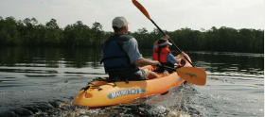  Leisure Canoe  (1PAX/2PAX/3PAX/5PAX) | 11 (Tue.) ( )  12 (Wed.) ( )  13 (Thu.) ( ) | 11:00 ( )  12:00 ( )  13:00 ( )  15:00 ( ) | 1 PAX ( )  2 PAX ( )  3 PAX ( )  5 PAX ( )
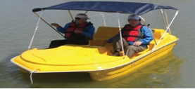  Paddle boat  (2~4PAX) | 11 (Tue.) ( )  12 (Wed.) ( )  13 (Thu.) ( ) | 11:00 ( )  12:00 ( )  13:00 ( )  15:00 ( ) | 2 PAX ( )  3 PAX ( )  4 PAX ( )

Information of Passengers
(*Please write down name and e-mail address of all passengers)
 | Name | E-mail
1
2
3
4
5

* If you want to know ICWE2019 program, Please visit : https://icwe2019.webengineering.org/program-2/
* Video of Water Sports (Korean): http://www.watersports.or.kr/sub04/sub04_0201.php
* Facility : Dressing room, Shower room, Toilet, Waiting room, Medical room

※ About Safety
- Safety training is conducted before water sports for participant’s safety.
- There are specialist-trained personnel for safety.
- In case of an emergency, there are life vests, rescue tubes, first-aid kits, water lifesaving tools, and cardiac defibrillators.
- In case of accidents, you are covered by the user safety insurance.
- Please follow the safety rules carefully.

※ REMARKS
- When the reservation is complete, I will send you an e-mail.
- The reservation is real-time, so the schedule progress may be different from the time you want.
- If you would like to cancel, please send me an e-mail to the Secretariat before June 7th (Fri.).
- Please send it to ICWE 2019 Secretariat. (icwe2019@icwe2019.org)

